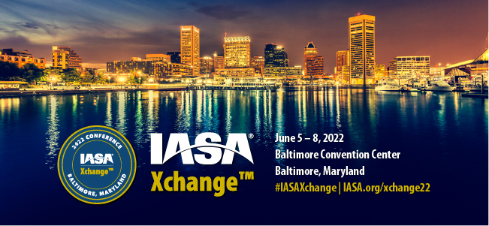

We want you to join us in Baltimore for IASA Xchange 2022!
Not sure how to persuade your boss to send you and fund the trip? Here are some simple steps to help you prepare for your request.
Timing is everything: Know when to ask. Explain that you need to purchase during a certain time to get the early bird special. If you have regular one-on-ones, it may be good to talk to them during this time that they have blocked off.
Tell why: Create an agenda for yourself of all the sessions and networking events you want to attend.
Make an outline with bullet points or justifications on why it will benefit you, your clients and/or your company. Show that you will make the most of it, and why networking and attending the sessions are important. Ask yourself what your short-term and long-term goals are with your organization’s objectives, and pair them with sessions that will contribute the most to the goals. Explain how it will make your company more profitable, functional, and flexible.
Explain the top reasons why you should go. Here are some examples.
- Networking – Networking is important. The best of the best come to the conference with insights from their experiences and new ideas. I will have the opportunity to meet influencers, speakers, and the leaders in the industry. I can address them with problems we face and get advice, as well as collaborate and share ideas with one another.
- I will learn more about the industry and the latest innovations. Working at (company name) has my full attention and is a career I fully invest in. Attending the IASA Xchange 2022 will boost my knowledge and help drive myself and others to success.
- I can represent our company. I will prepare an outline or presentation of everything I learned at the conference and create a contact list of people and vendors I met. I can then report back to each team or manager, and explain what I learned that may help them.
Still need help? Try our email template by clicking here.

